**Poem in the voice of your excess time**

*in response to 'Falling Star' by Romare Bearden*

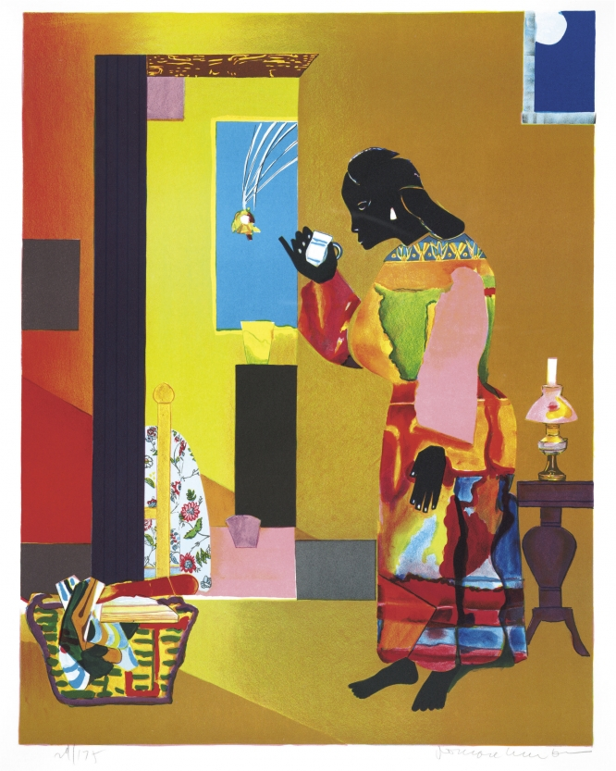

Once you kept flowers, gave vases to them, forgot  
vases stayed long after flowers died. When the house was new  
you were happy to be guided by lamps, feigning forgetfulness  
  
around the furniture you arranged. You forgot  
me. Thought that once given,

I would never return.  
  
But I did, drop by torrent. At first  
in minutes: the peak hour traffic, the extended  
appointments. I hid in your dinners, slowed,  
  
had to be heated. You tended to your flowers,  
gave them sun. Restaurant: his calls,

apologetic, your orders to the waiter:  
  
the set meal for one.  
The candles burned. I came back,  
put them out, kissed your eyelids; you rose from sleep,  
  
eyes stinging, listening to the darkness  
of the house. I pooled in your pots,  
drowned your flowers. You threw them away.  
  
I made my home in your ransacked laundry. You tried  
to hang them dry, but the creases  
would not allow. I surged, took over  
  
your house, ran your watercolour dress. Why resist,

sweetheart? You sobbed,

felt me clogging your lungs. You stopped lighting

the candles. Of course. Saw me in every pocket,  
thought me a fly when you poured yourself a drink.  
I *am* the drink. Now it is night.  
  
Give yourself to me. Now your body  
a meandering shadow, earrings  
glinting the moon’s light.